Name: __________Logan Passi__________  
Date: _____________________

1. What is good and bad about RAM as storage for the operating system and data? – 2pts

What is bad is that it is volatile storage so the data will be lost once the computer is shut off.

What it is good for is for holding temporary data that does not need to be kept once the computer is shut off.

1. As you increase the number of processors by N, is the speedup ratio also N? Why or why not? – 2pts

No it is not N, because if we have more processors they will also be using more resources.

1. What could you use a cluster for? – 1pt

A cluster could be used to reduce calculation time for intensive scientific calculations.

1. Where would you store a small amount of data, say a 32 bit integer – on the heap or stack? Why? – 1pt

It would be better to store smaller data on the stack because it can hold less data than the heap and you do not want a stack overflow.

1. Where would you store a large data structure (32MB+) on the heap or stack? Why? – 1pt

On the heap because the heap and hold more data than the stack.

1. Please fill in the blanks that describe the migration of integer A from disk to register (hint-pg 28): - 1pt

**Magnetic disk**

**C?**

**B?**

**A?**

A: ______________main memory_________

B: ____________cache___________

C: _____________hardware register___________

1. Please write an application (language of your choice but they MUST use system calls) that moves a file (ie implements mv command) in the platform of your choice (Windows or Linux).

Hint 1: I have an example of the cp command that uses system calls in C/C++ for Windows and Linux

Hint 2: unlink for Linux (<http://linux.die.net/man/2/unlink> ) and DeleteFile (<http://msdn.microsoft.com/en-us/library/windows/desktop/aa363915(v=vs.85).aspx> ) for Windows. – 3pts

**PLEASE NOTE – if your code DOES NOT use system calls you will receive a 0 on this assignment.**

1. Please write an API that wraps the code for the cp command such that the function has a prototype of: - 3pts

void cp(const char * src, const char * dst)

Hint 1: It’s simpler than you think

Hint 2: Look at the sample code

**PLEASE NOTE – if your code DOES NOT use system calls you will receive a 0 on this assignment.**

1. What benefits are there to a micro-kernel? What benefits are there to a monolithic kernel? Which would you use and why? -2pts

A micro kernel provides more security and reliability. A monolithic kernel provides cpu, scheduling, memory management, file management and other operating system functions through system calls. It depends on the situation to determine which one to use, you would have to look at the pros and cons of each kernel and see which one is better for your situation.

1. At what level ring/layer allows full unrestricted access to the hardware? – 1pt

Ring 0

1. Name 3 tools from either Windows or Linux that allow you to inspect system information and state what information they show. – 2pts

Task manager, Performance Monitor, Process status. These tools can show you real time statistics about how your computer’s resources are being managed, current processes and various other information.

Extra credit:

1. In class we discussed two modern ways that people interact with the operating system (CLI/Shell and GUI). Today we interact with these interfaces, usually, with a keyboard and mouse. What other way(s) could one interact with the operating system? (Hint: It’s currently being researched/developed and Microsoft has their own concept(s):

<http://www.youtube.com/watch?v=a6cNdhOKwi0> ) – 2pts

1. In the git repo I provide sample code from MikeOS (<http://mikeos.sourceforge.net/write-your-own-os.html> ). After you use the provided scripts to download the necessary tools to work with this code, the assignment is to see if you can add some color to the output. ie turn this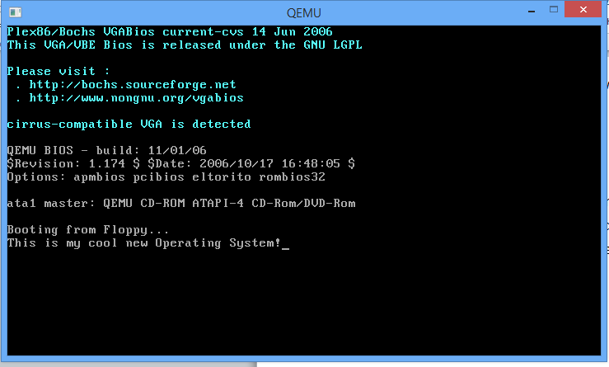  
   To this (be creative!): - 4pts 